Name: Vaishali Pandey

Roll No: A046

SapId: 86062300053

MSc SDS Batch 2

# Cloud Computing Practical 2

1) Uploading a file, video, etc

Steps:

Open Amazon Web Services (AWS) and login in the services. Search S3 on the search tab. Click on S3.

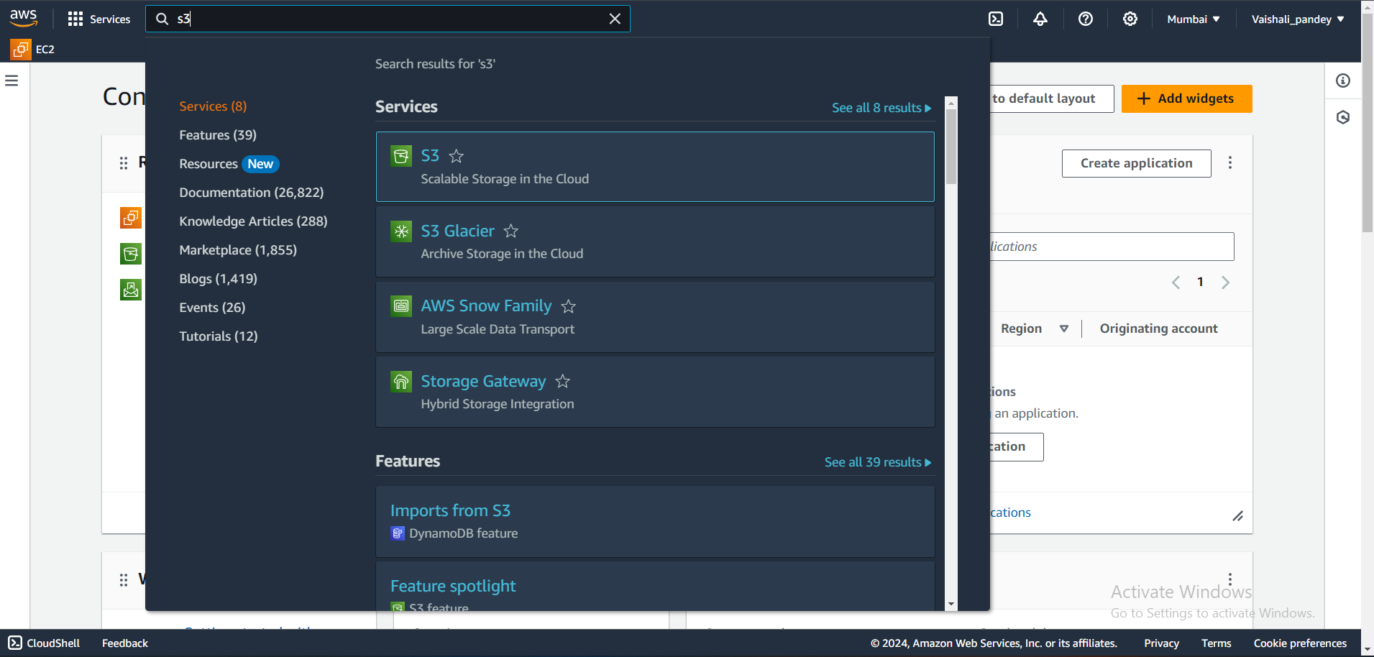

Then Click on Create Bucket

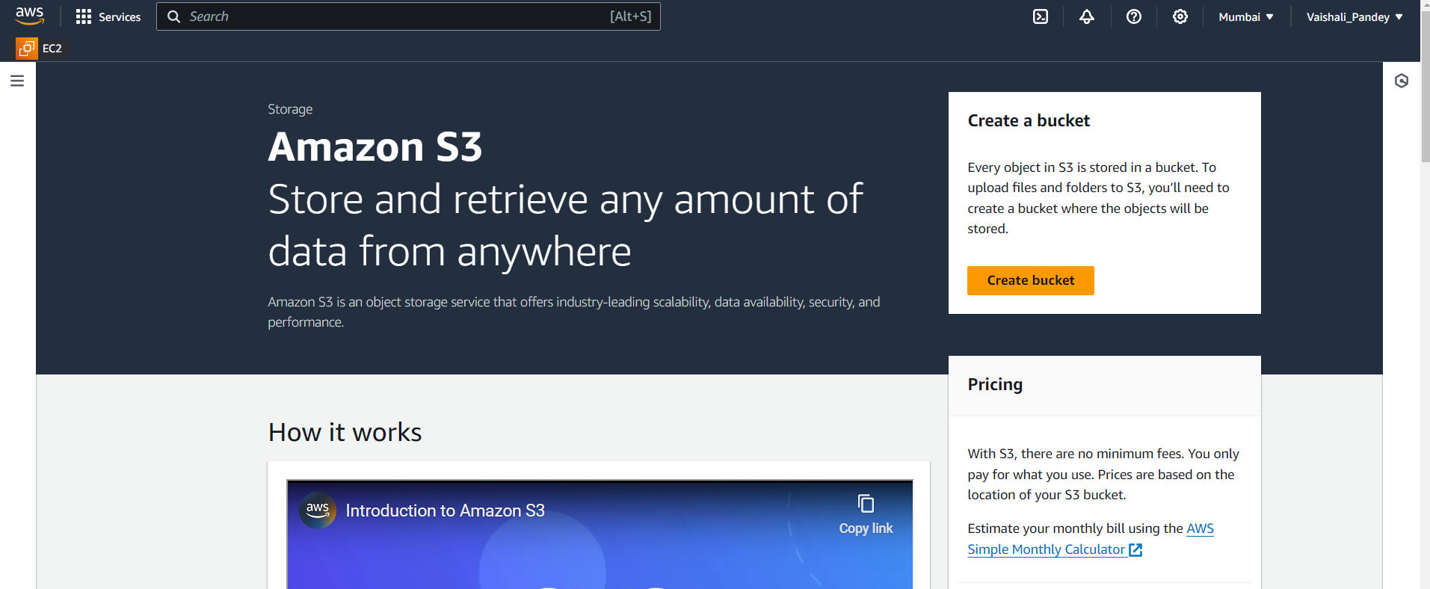

Give name to the bucket

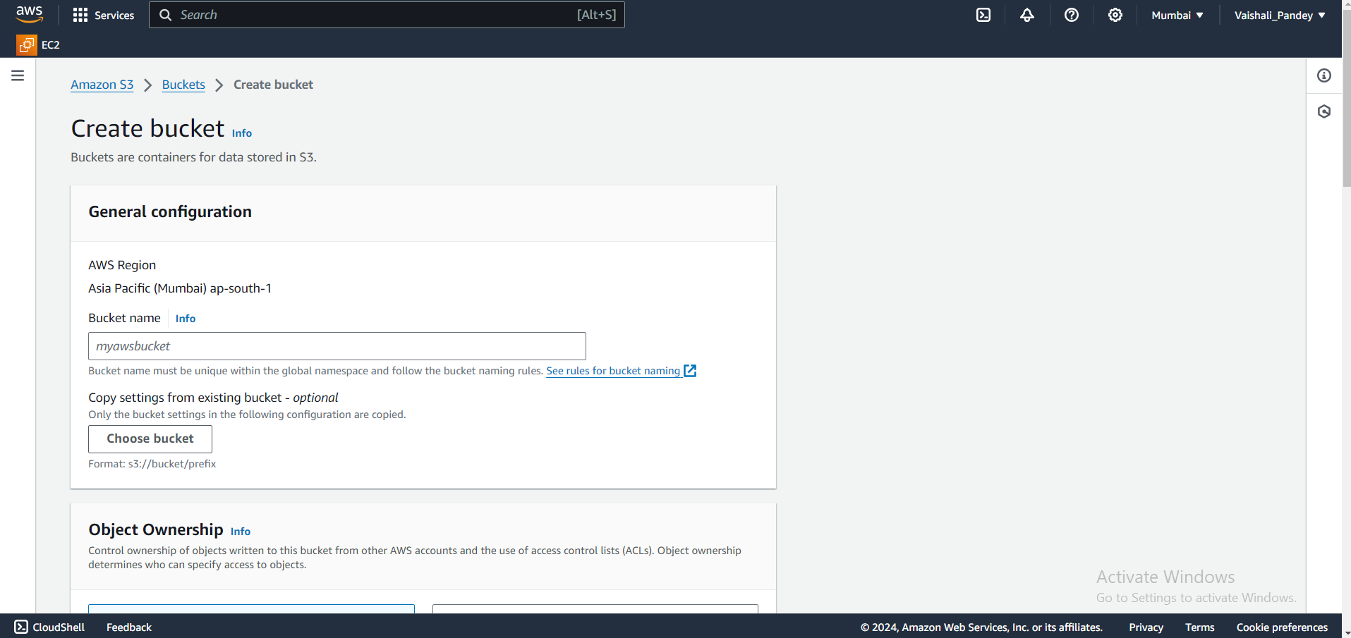

Please ensure that you click on block all parties if it is not turned on and let the others options be in default.

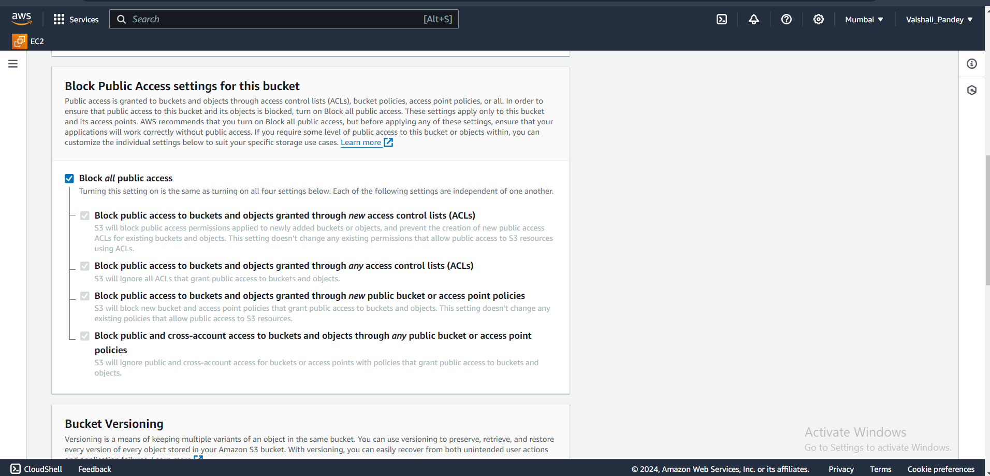

Then click on Create Bucket.

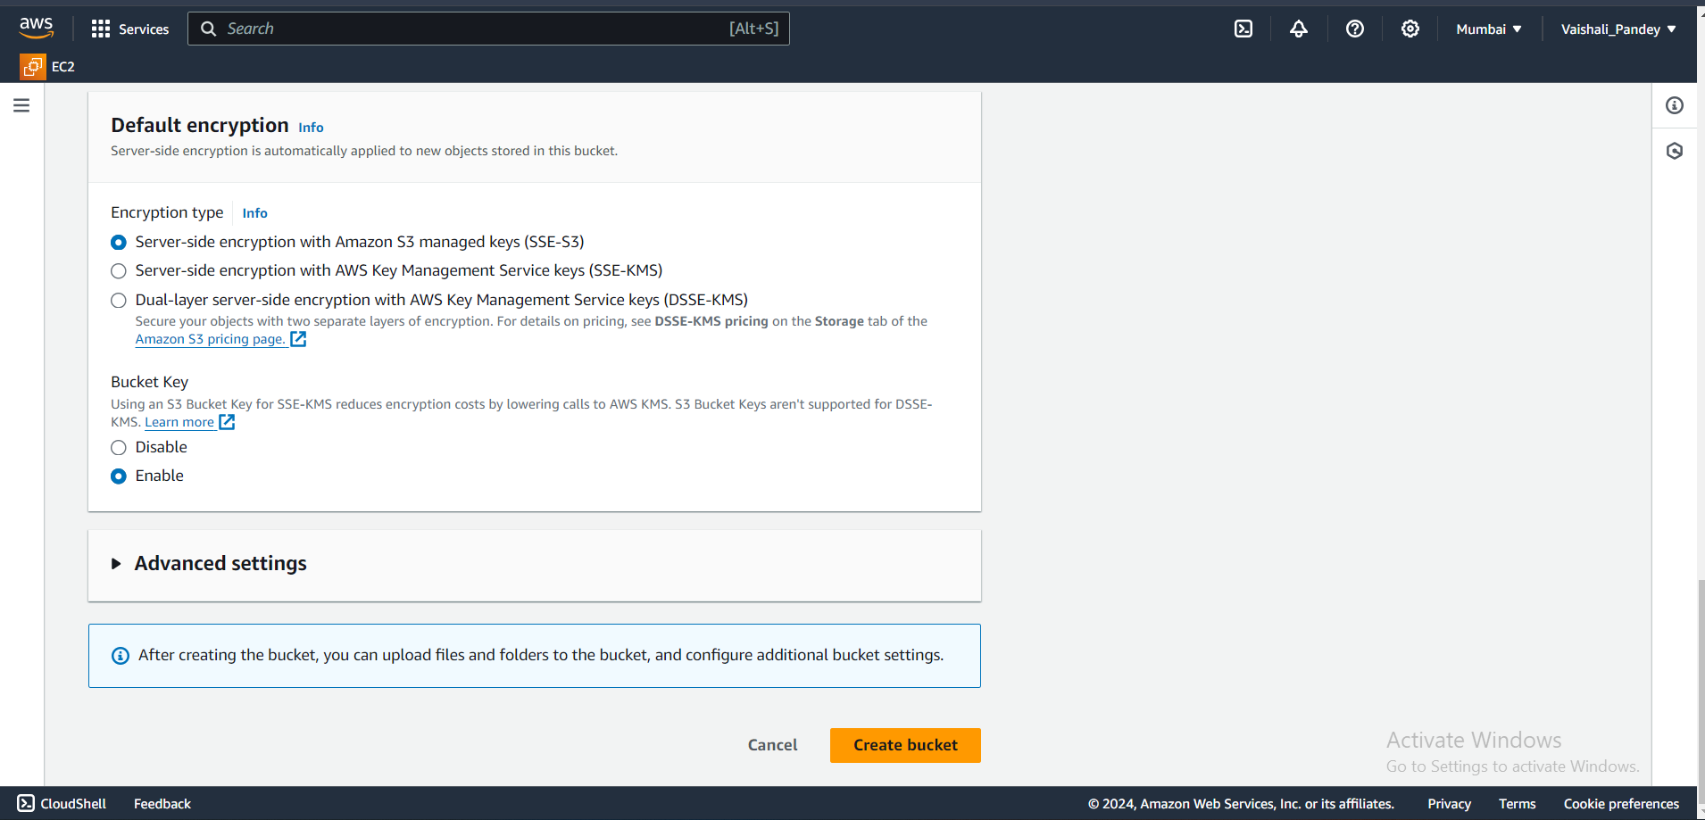

Click on ccimageprac2 i.e the name of the bucket here.

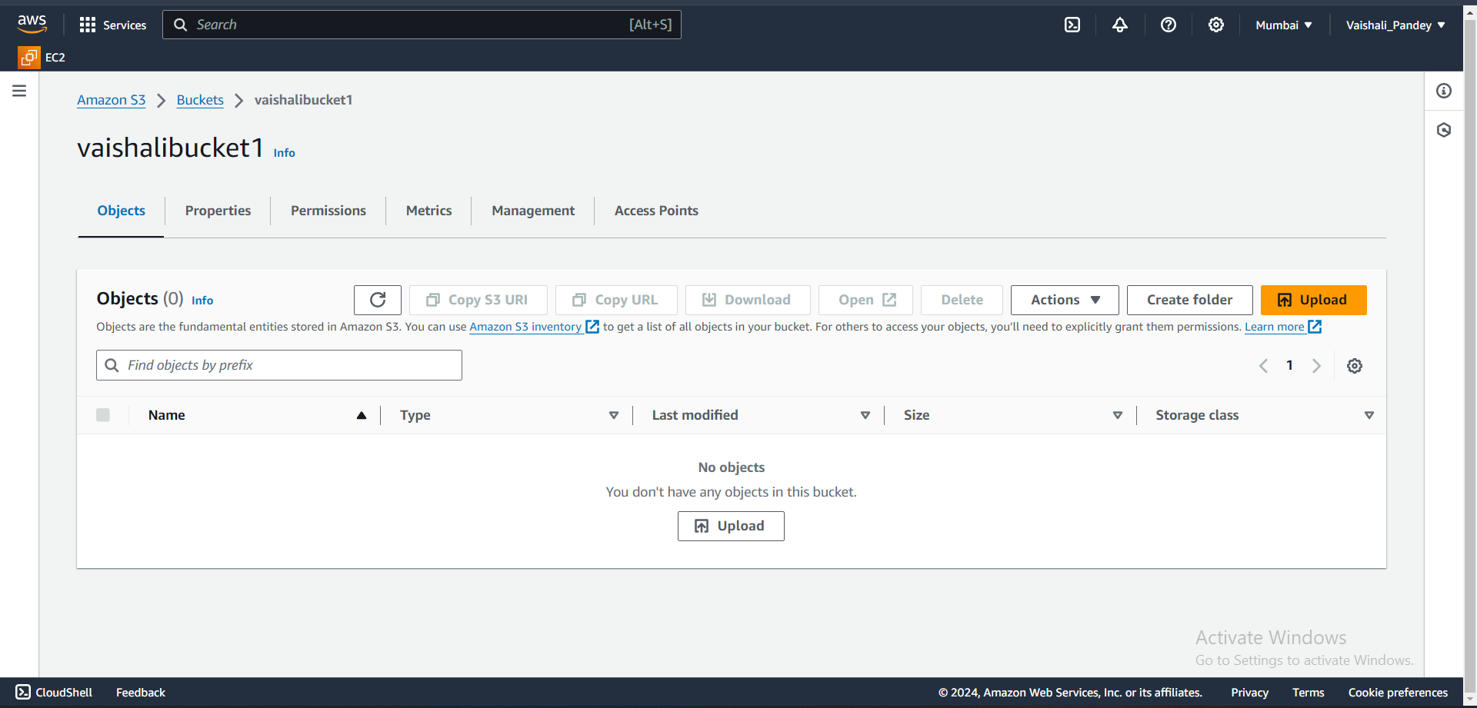

Click on Upload.

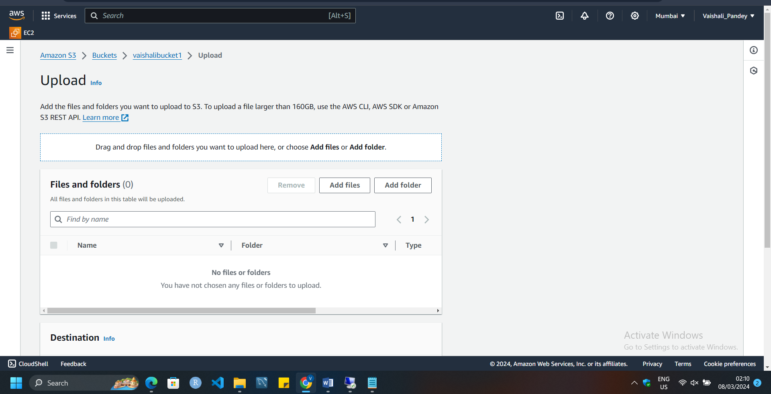

Click on Add files and add the image from your pc, and then click on Upload button.

Now you have successfully uploaded the image and to check your image click on the link inside the Name of the Files and Folders.

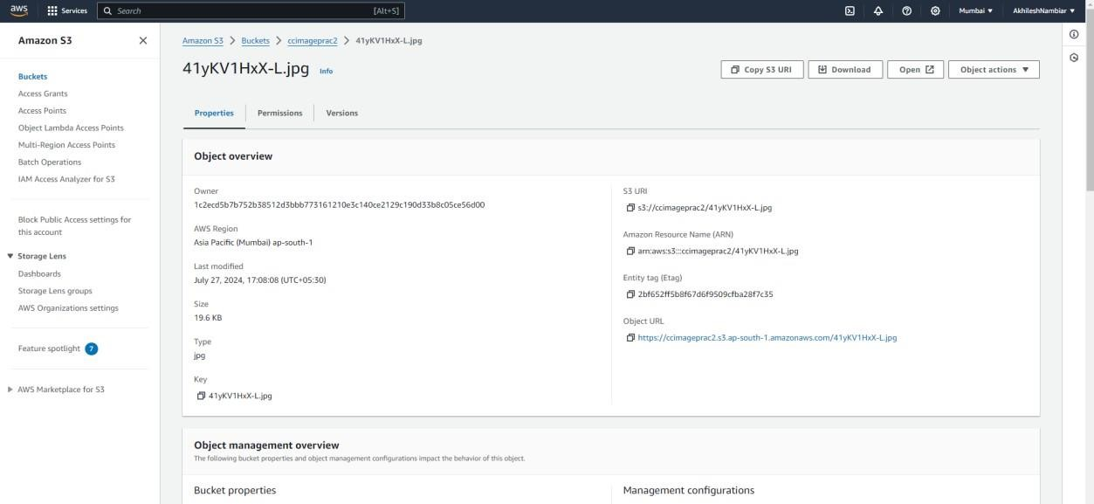

Click on the open button then you will get the uploaded image.

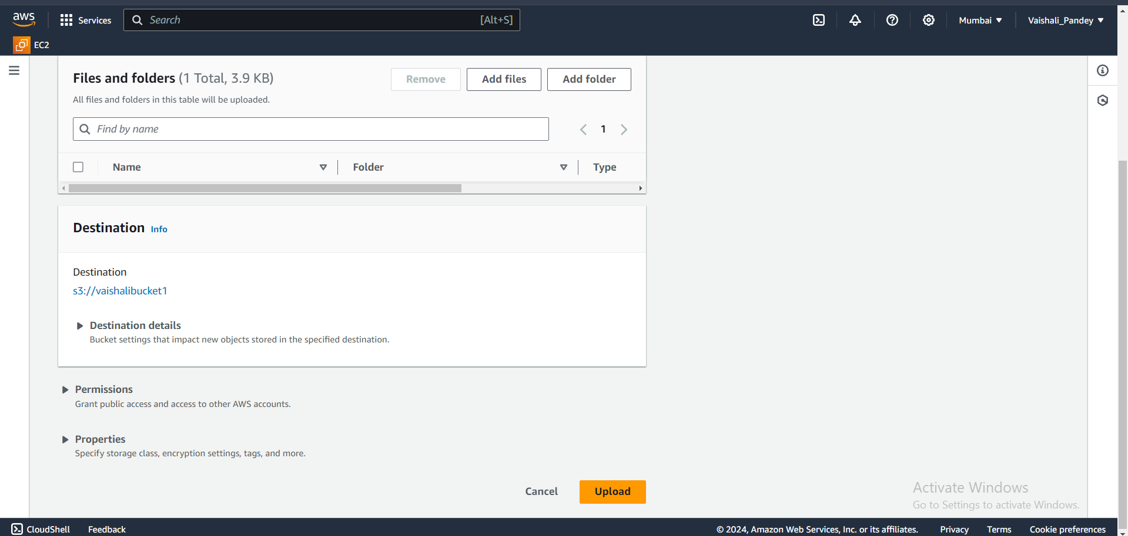

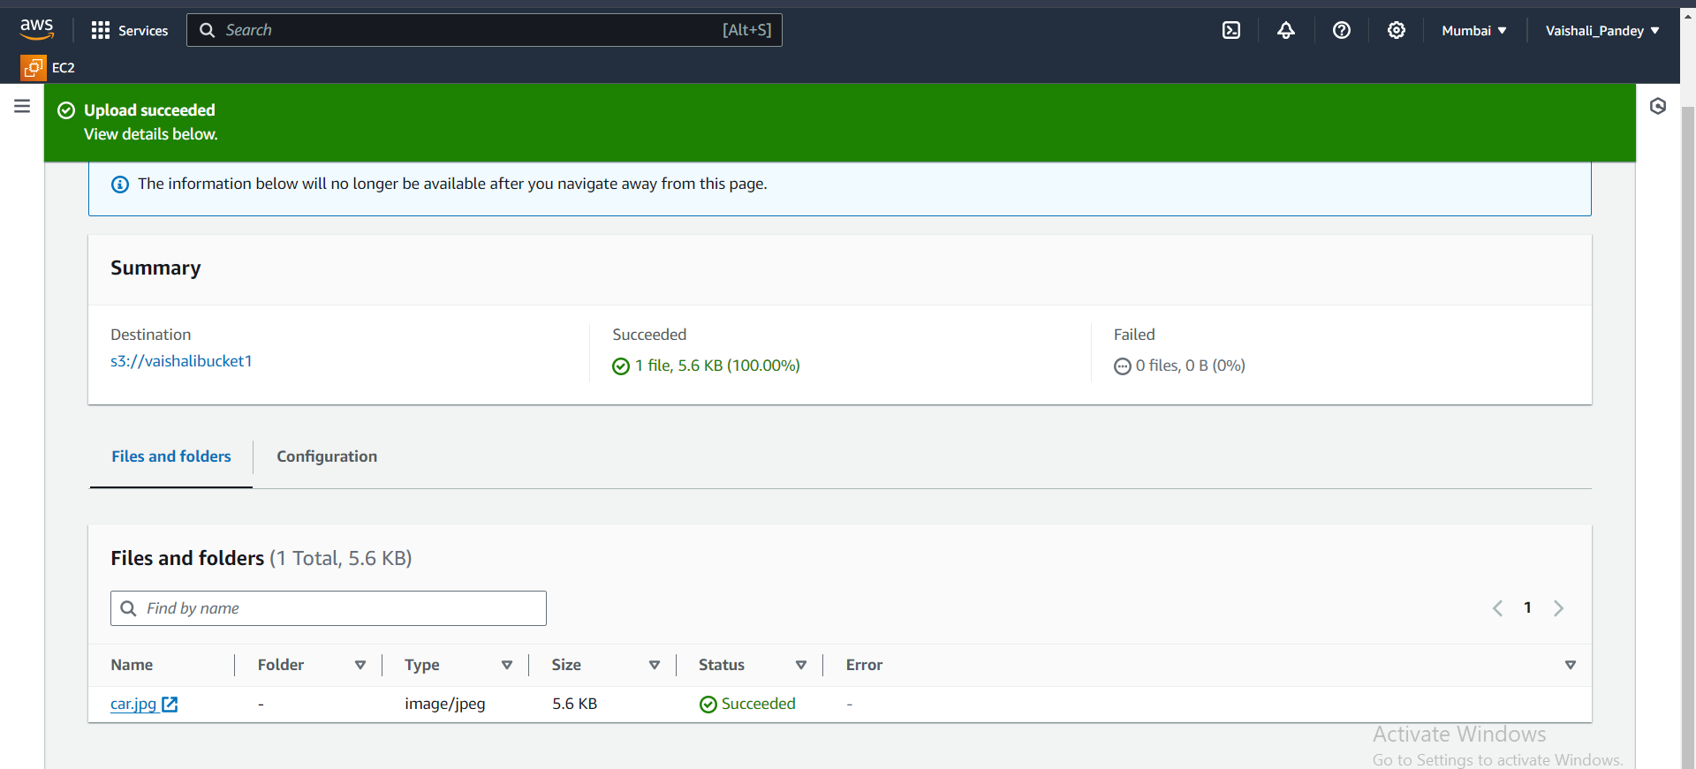



Uploading a static website:

Click on Create other bucket for creating another bucket for creating an html webpage that will open in the AWS. Proceed the above process again.

